**Modeling Toolbox Readme Part 2. Going from Model to Voltages.**

Part 1 is in “\Modeling Toolbox 2019\Modeling Support Files\Nerve Tracing”, and is called ‘Making Models’

**Get Voltages (Short version)**

1. Check that you have a .sm2 file in “…\Modeling Toolbox 2019\”
2. Check that you are running matlab from “…\Modeling Toolbox 2019\”
3. Open Process_Sm2_2019
4. Tune anything you want tuned
5. If there’s something you want to keep in “…\Modeling Toolbox 2019\Intermediate Outputs\”, make a backup. Otherwise, delete the contents of the folder.
6. Hit run
7. [Wait ~24 hours]
8. Open Process_Intermediates_2019.m
9. Customize how you want axons positioned and voltages interpolated
10. Hit Run
11. Everything you need is now in …\Model Outputs\

**Example continued from Readme part 1**

Your folder should look something like this. Notice the SM2 file at the bottom.

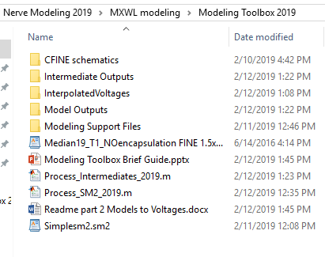

Open ‘ProcessSM2_2019.m’ and change the name of the sm2 file.

Go through the file, and change any parameters you think are needed (for this example, nothing). This defines the actual Maxwell model.

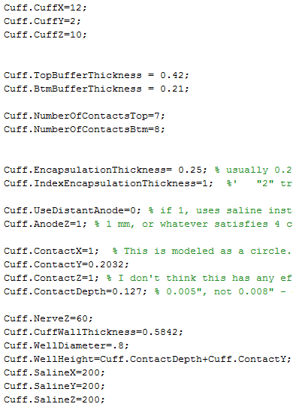

When you’re done, hit “Run”.

The intermediate outputs folder will start populating, and will look something like this:

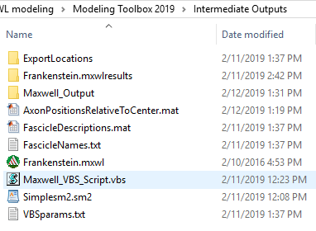

And Maxwell will open and start generating your cuff.

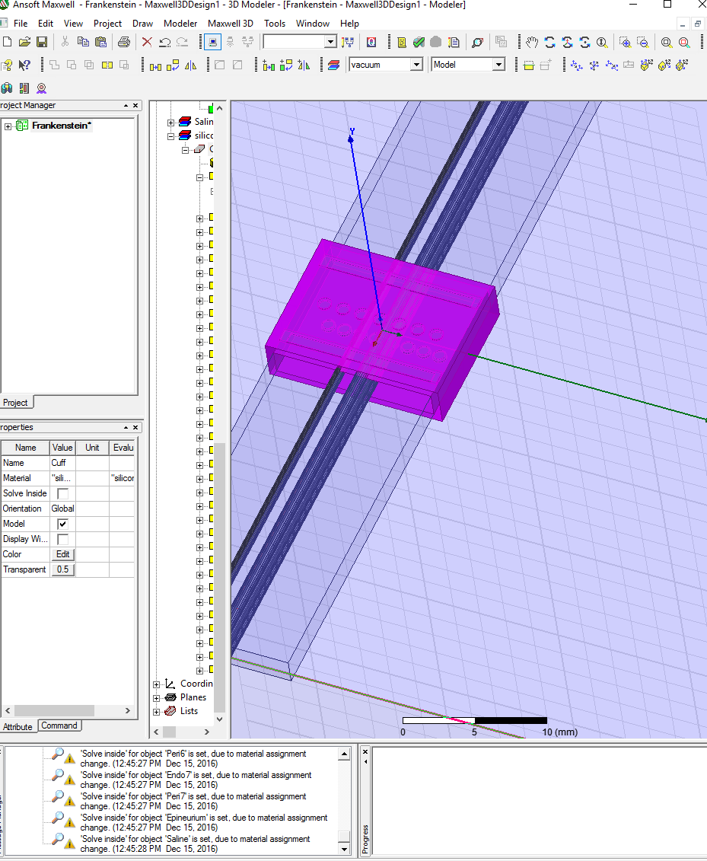

If it throws you errors like these:

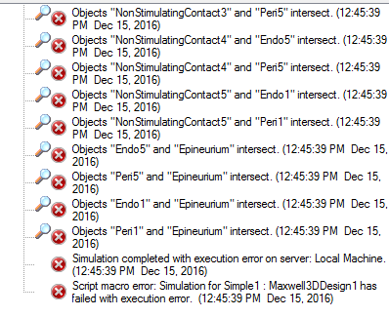

Something is wrong with the trace (like in the image below) and you’ll have to start over

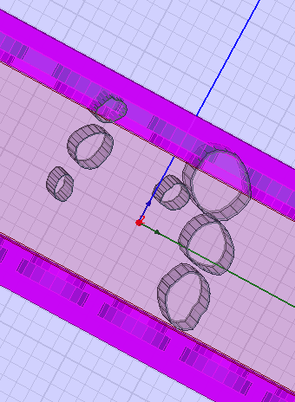

Assuming that doesn’t happen, you should have a bunch of exported voltages in the /Maxwell_Output/ folder

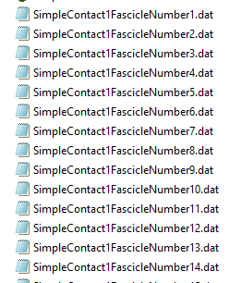

The .mxwlresults folders hold most of the data, but aren’t useful. Feel free to delete them to save space.

Continue by opening Process_Intermediates_2019.

Customize this section. You probably want the ‘random’ functions, which randomly position axons with random diameters and offsets. The ‘Grid’ functions randomly position axons, but give you voltages for every diameter/offset combination at each axon position. If you want to look at how effects change with diameter size, ignoring offsets, use those data files.

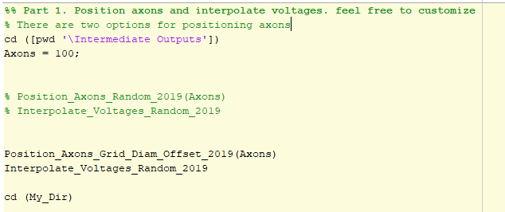

Hit “Run” on Process_Intermediates_2019.

The ‘Model Outputs’ folder will populate and look like:

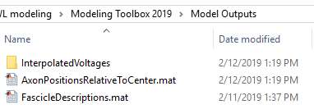

Useful things to know:

AxonPositionsRelativeToCenter should be used for drawing

FascicleDescriptions should have the number of fascicles